HETSLAYER – PRESENTER PACK (RADIO)
For Immediate Airplay & Interview Consideration

ABOUT THE PROJECT
At a time of increasing hostility toward trans and gender-diverse people, this project is both a cultural offering and an act of defiant self-definition. Hetslayer’s debut album Not My Problem was created to elevate trans and gender-diverse voices through unapologetic storytelling, analogue grit, and community-powered music-making. Rooted in queer resilience and razor-sharp political edge, Hetslayer hits hard with raw honesty and a sound that refuses to be softened.
Recorded entirely to tape at Sound Recordings in Campbells Creek with engineer Alex Bennett, the album captures every breath, break, distortion, and moment of resistance. The record was later mastered by Casey Rice, with striking cover art by local artist Emma "Ruby" Armstrong Porter.
Deeply tied to Castlemaine’s queer community, the album features guest appearances from musicians including Claire Spooner, Jess Parker, and a full choir of gloriously queer voices. The result is both a powerfully personal statement and a collective act of visibility, defiance, and strength.
For Hetslayer, making this album is an act of claiming space with courage. It centers trans and gender-diverse people not as tokens or footnotes, but as essential voices shaping our cultural narrative — producing a cultural artifact that will endure and inspire generations to come.
Art is never neutral. Hetslayer’s music illuminates the full spectrum of trans experience: joy, rage, misinterpretation, and exclusion. Each song functions as both vignette and protest, pushing back against systemic erasure. Trans voices have long been absent from mainstream culture. Not My Problem stands as both sonic archive and act of resistance — documenting trans liberation, creativity, and resilience for current and future generations. It will not be marginalised; it will be archived, distributed, stocked, and celebrated — rightfully so.

NEW SINGLE RELEASES
First Single Release: Danger
Release Date: 4 December 2025 — in solidarity with 16 Days of Activism 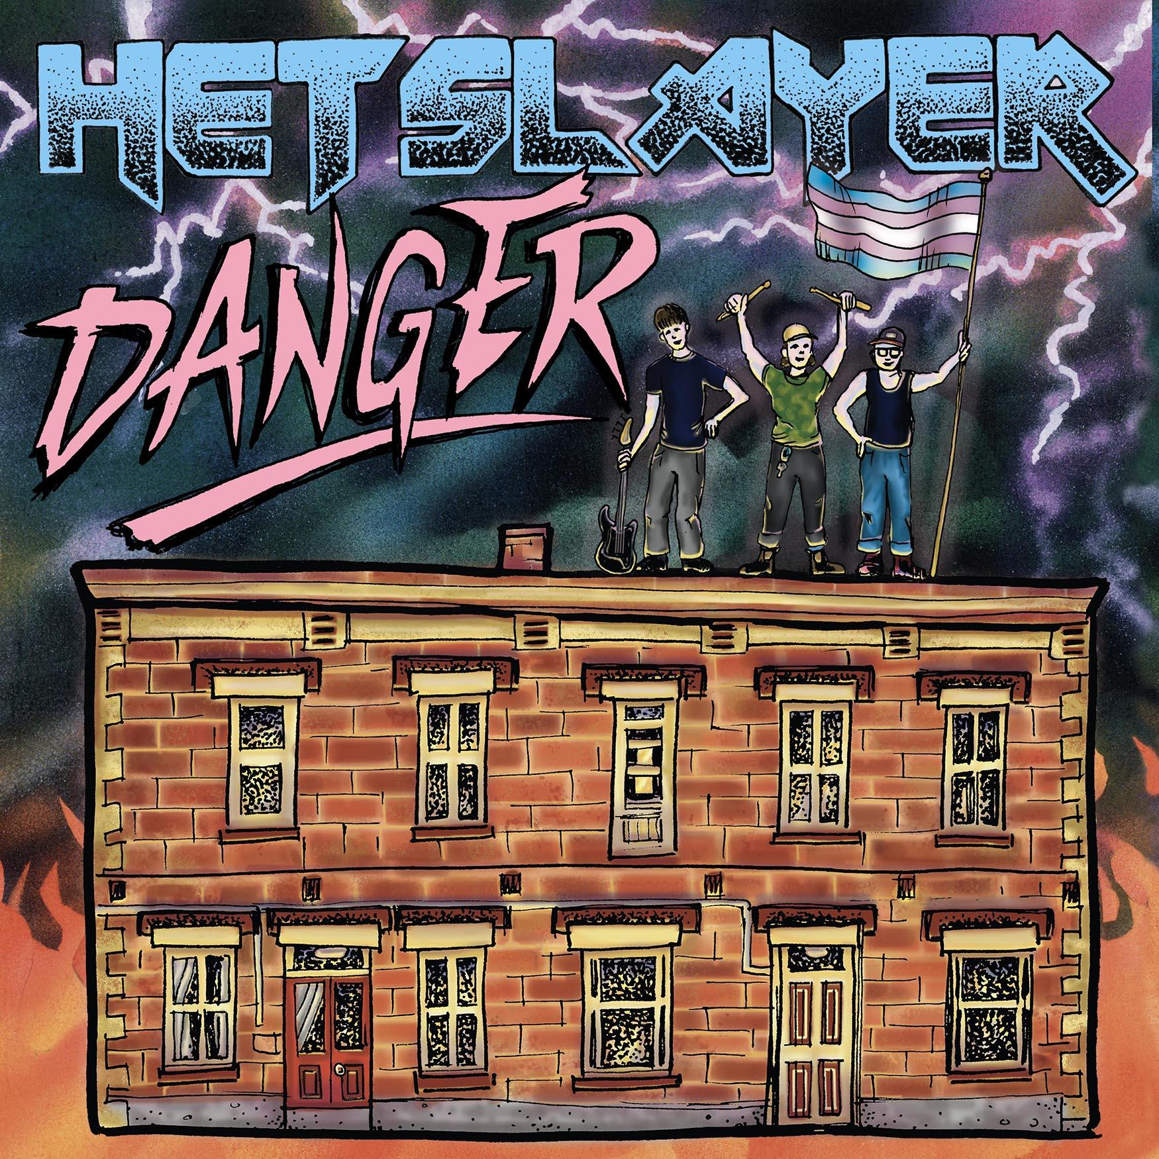
A daring, unapologetic anthem confronting the very real danger that men can pose to the community.
Dark, pulsing and unflinchingly direct, Danger explores threat, survival and queer strength.
Talking Point:
An Australian study found that 76% of LGBTIQA+ people have experienced sexual violence, with over 80% of perpetrators being cisgender men — a stark truth that frames the emotional landscape of the song.
Feature spots: Claire Spooner plays additional guitar. Jess Parker on backing vocals.

Second Single Release: Clown Fish
Release Date: 18 December 2025
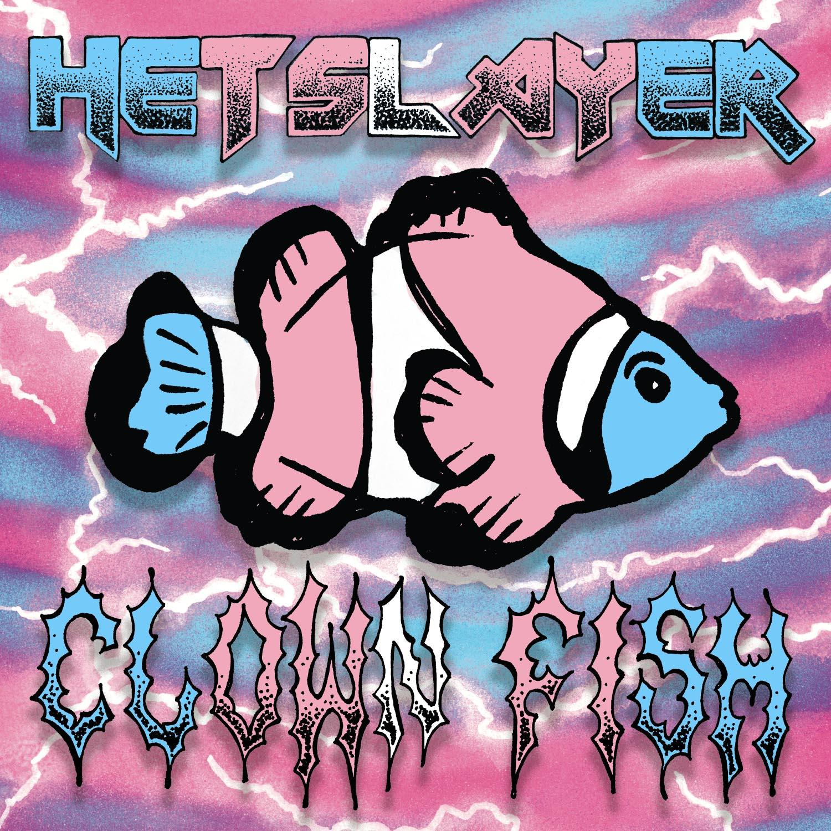
A sharp, satirical and emotionally incisive track, Clown Fish pulls humour from discomfort with disarming precision. Through metaphor, absurdity and biting lyrical wit, the song interrogates identity and the gendered expectations placed on the human experience — reminding us that queerness and gender non-conformity are not anomalies, but exist throughout nature itself.
Feature spots: additional gay voices/harmonies from across the Castlemaine community.

Third and final Single Release: Hey Bro
Release Date: 1 January 2026
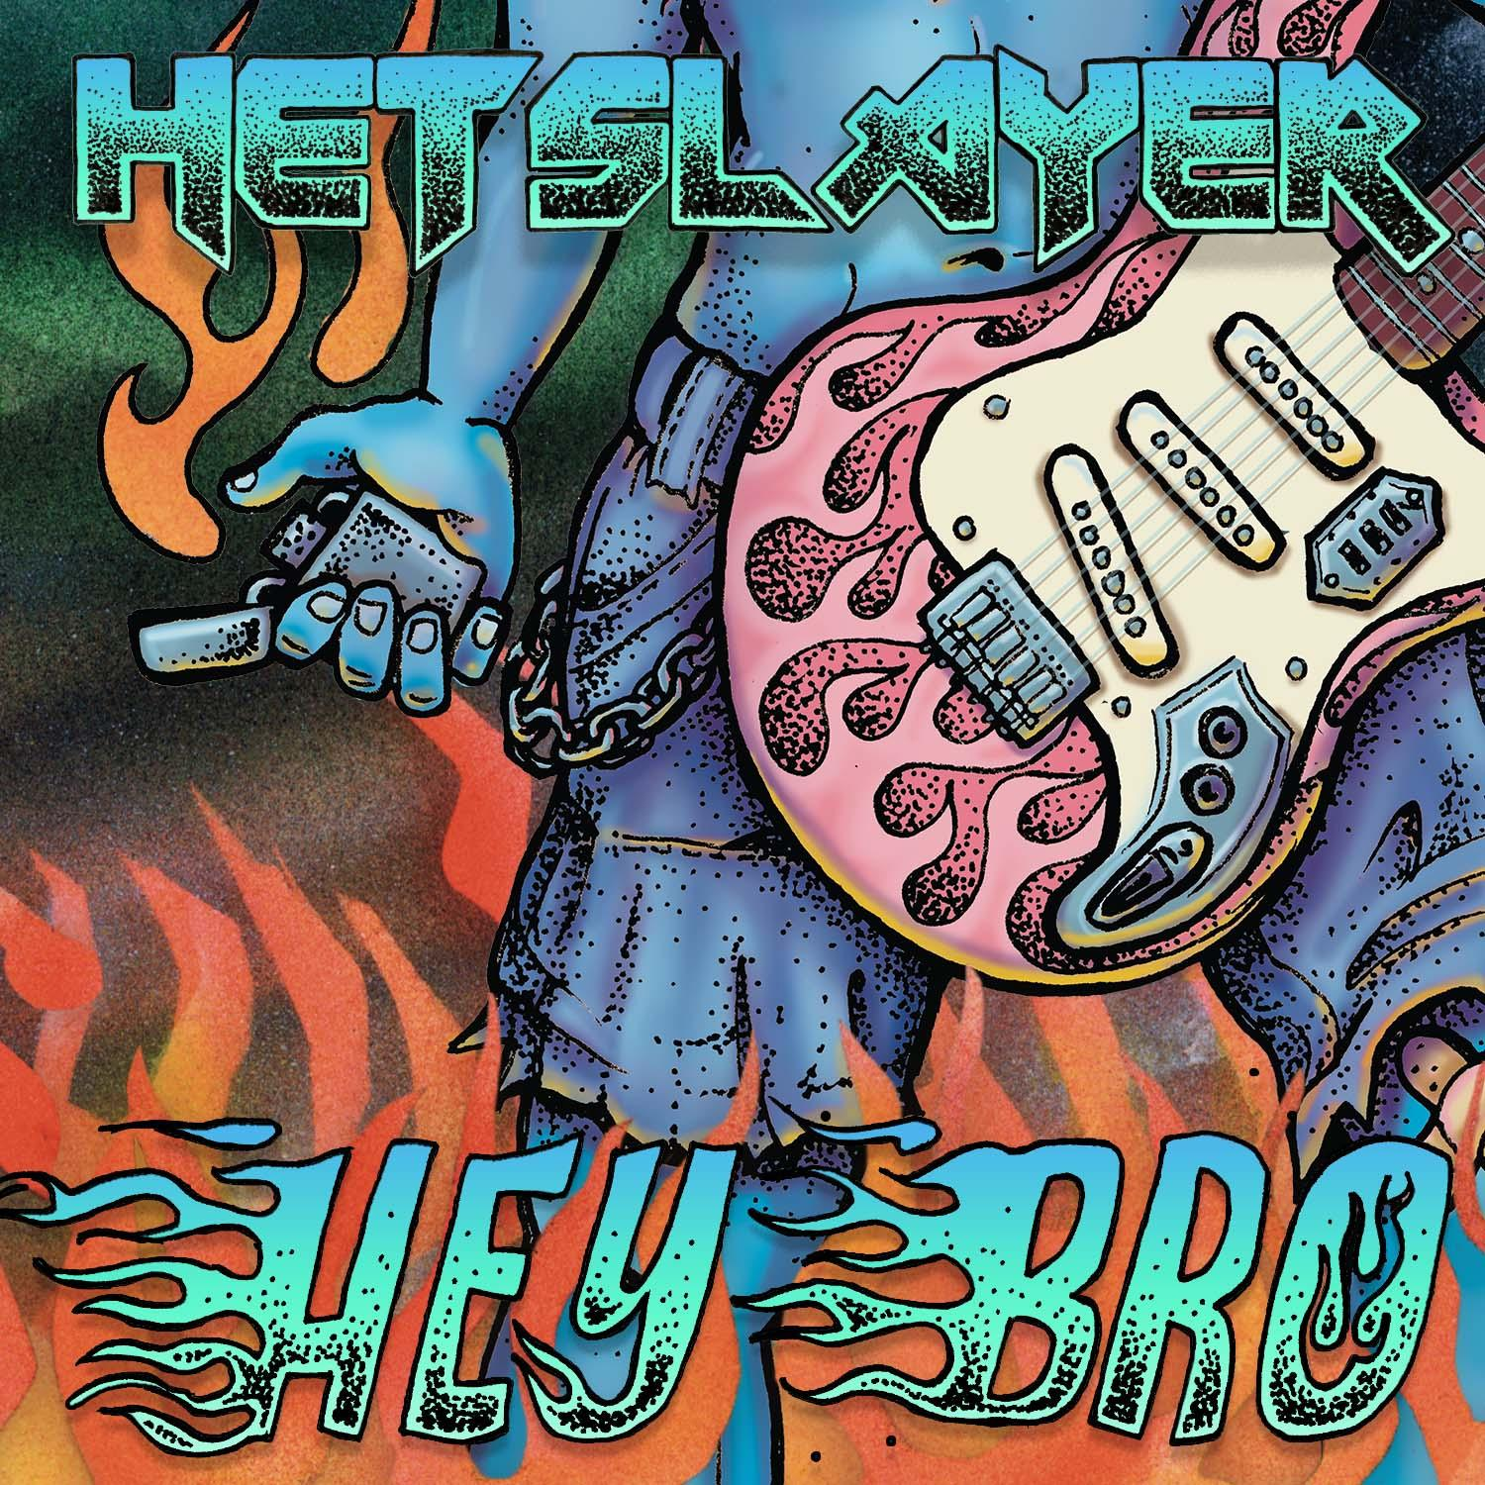
Hey, Bro! Is the feel-good hit of the summer…
A middle finger to the binary and every neat little box.
This track celebrates the in-between — messy, loud, real — where so many of us actually live.
If you live outside the lines, this one’s for you.

Third and final Single Release: Hands On Dad
Release Date: 15 January 2026
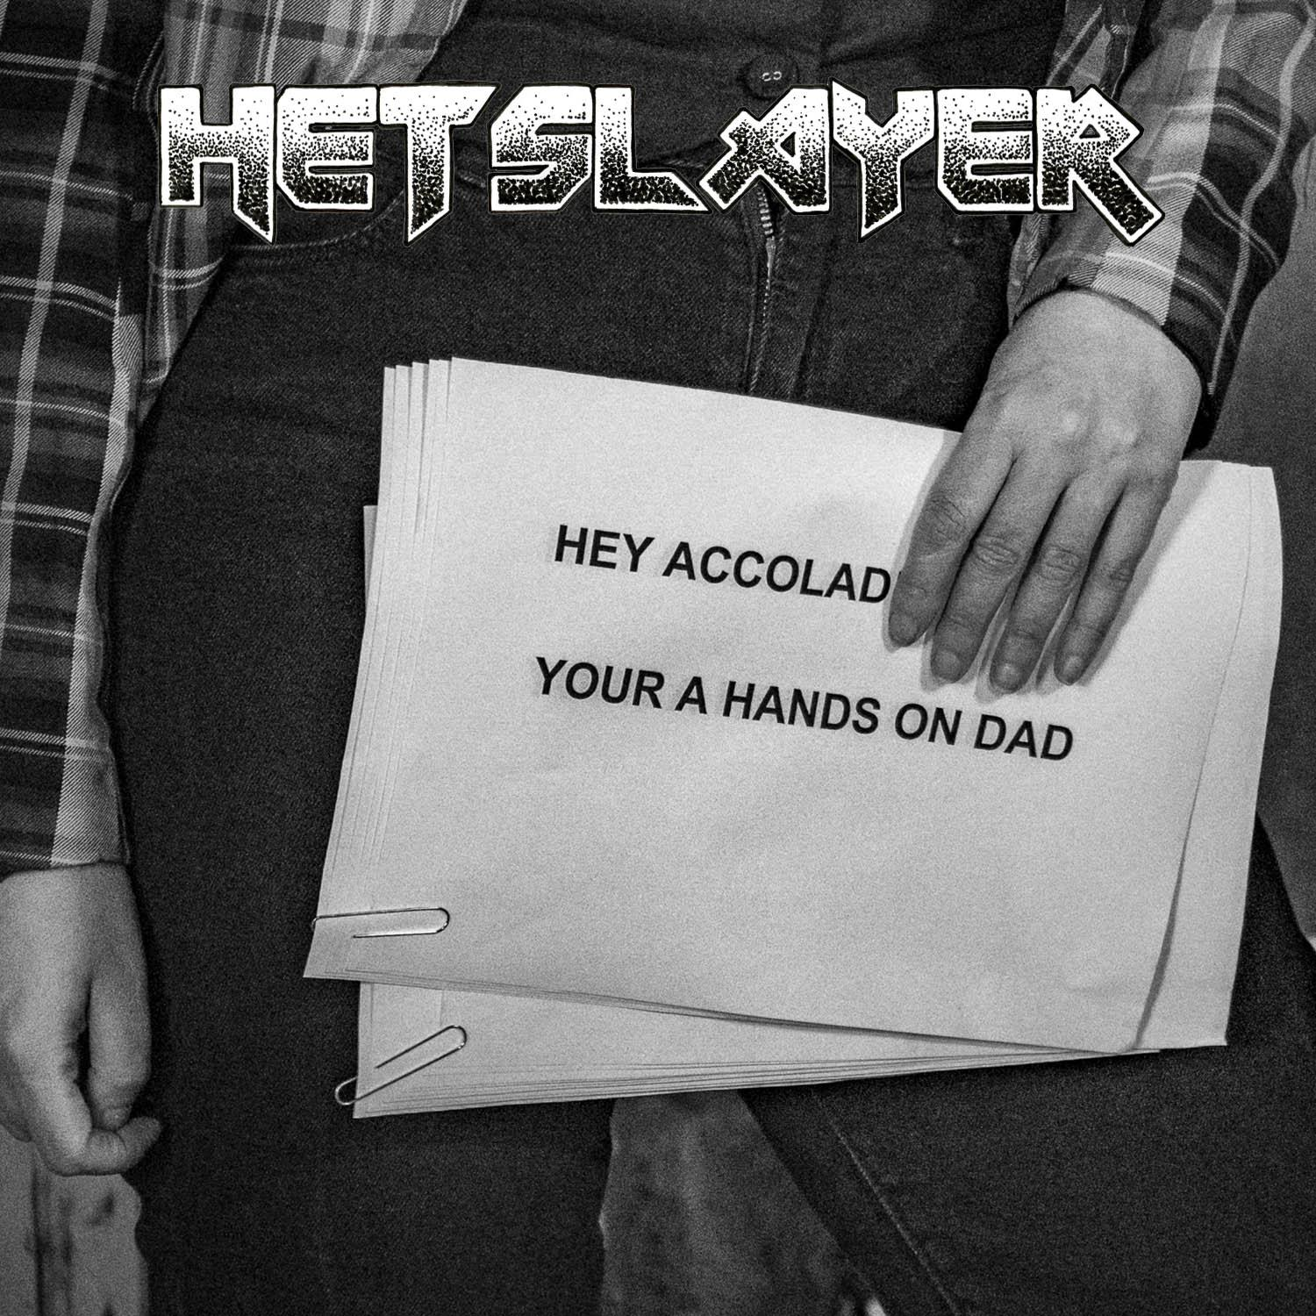
The last single before the album drops…
This one digs into the patriarchal double standards of parenting that many of us grow up with.
Hetslayer is calling out the quiet harm hiding in plain sight.
Feature spots: Kai (they/he) — the youngest voice/shout-outs, bringing fresh energy from the halls of high school. Kai also shadowed and assisted sound engineer Alex during studio sessions.

ABOUT THE ALBUM — NOT MY PROBLEM
Album Online Release Date: 29 January 2026
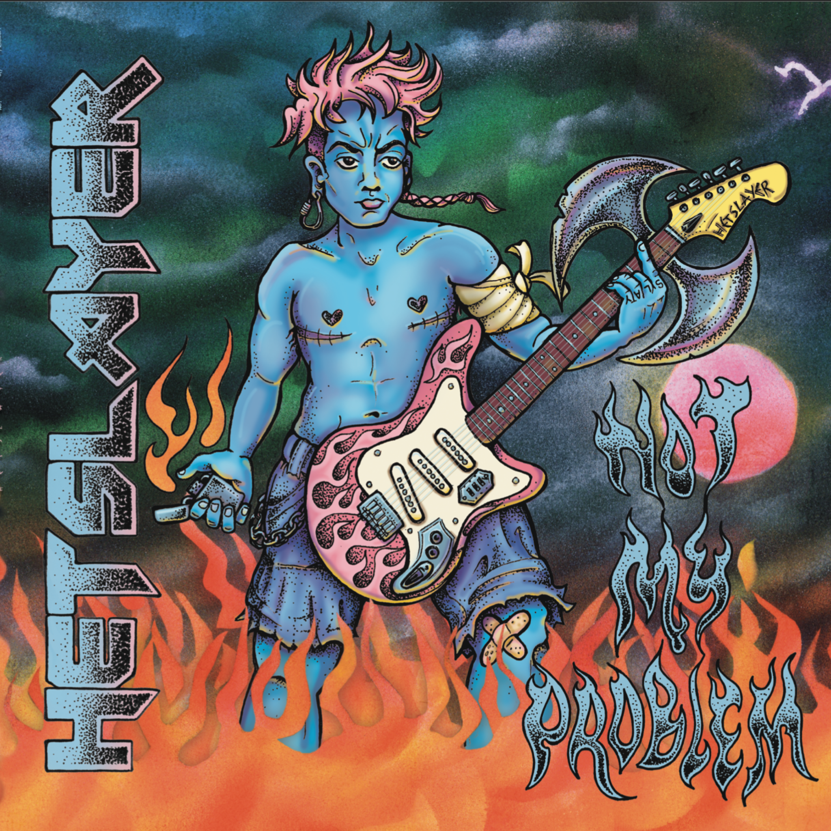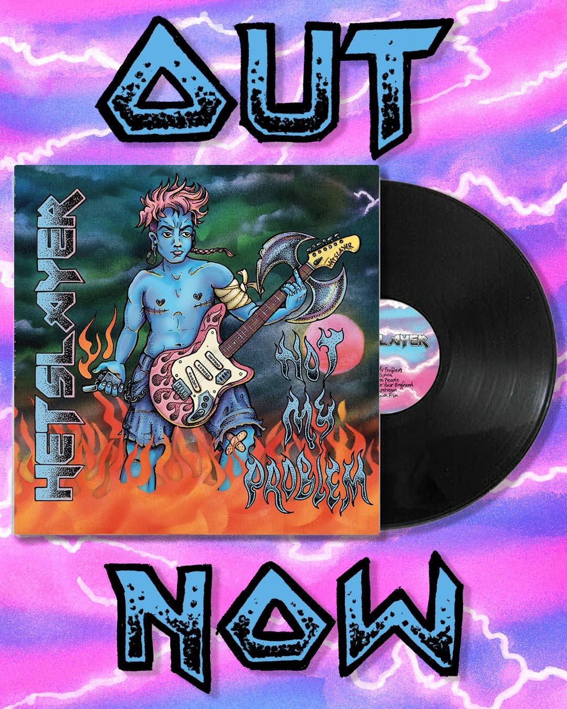
Not My Problem is Hetslayer’s debut album — a cathartic, razor-edged punk journey, rooted in identity, autonomy and trans resilience. Sonically it draws on analogue textures, distorted guitars, and relentless emotional clarity. Lyrically, it’s a reclamation of narrative: blunt, wry, sometimes devastating, often defiantly funny.
This body of work sits at the intersection of personal and queer history and community strength, emerging from, lived experience and collective queer collaboration across Dja Dja Wurrung Country (Castlemaine and surrounding areas).
RECORD LAUNCH – EVENT DETAILS
HETSLAYER – Not My Problem ALBUM LAUNCH
Date: 31 JAN 2026
Venue: The Diggers Store, Campbells Creek
Time: Doors open at 5:00 PM
Local chaos starts with Claire Spooner at 5:30 PM
Followed by Paddock Bomb at 6:15 PM
Then, at 7:00 PM, Hetslayer slays the stage.
Tickets: $20/$15 at castlemainepride.org.au
This is an all-ages and alcohol-free event.
Expect high-energy, sound politics and unapologetic queerness, in a space where LGBTQIA+ voices take center stage.

INSTORE APPEARANCE / RECORD SIGNING @ TABLE RECORDS
Date: 1 FEB 2026
Venue: Table Records, 16 Hargraves St, Castlemaine
Time: 11:30 AM - 12:30 PM
Free entry - all ages and attitudes welcome.
Don't miss your chance to connect with the band and get your record signed!

FOR RADIO PRESENTERS
- Single releases: Bandcamp HERE
- Social Media tiles / promotional assets HERE

CONTACT
Cristina Pantazis
Project Coordinator I Castlemaine Pride
Phone: 0438 512 114
Email: castlemainepridefestival@gmail.com
Socials: https://www.instagram.com/castlemaine_pride/
Han, Bec + Alex
Hetslayer
Email: hetslayer@gmail.com
Socials: https://www.instagram.com/hetslayerband/
Zeb + Jaxson
Garden Seat
Email: gardenseatlabel@gmail.com
Socials: https://www.instagram.com/gardenseat/

