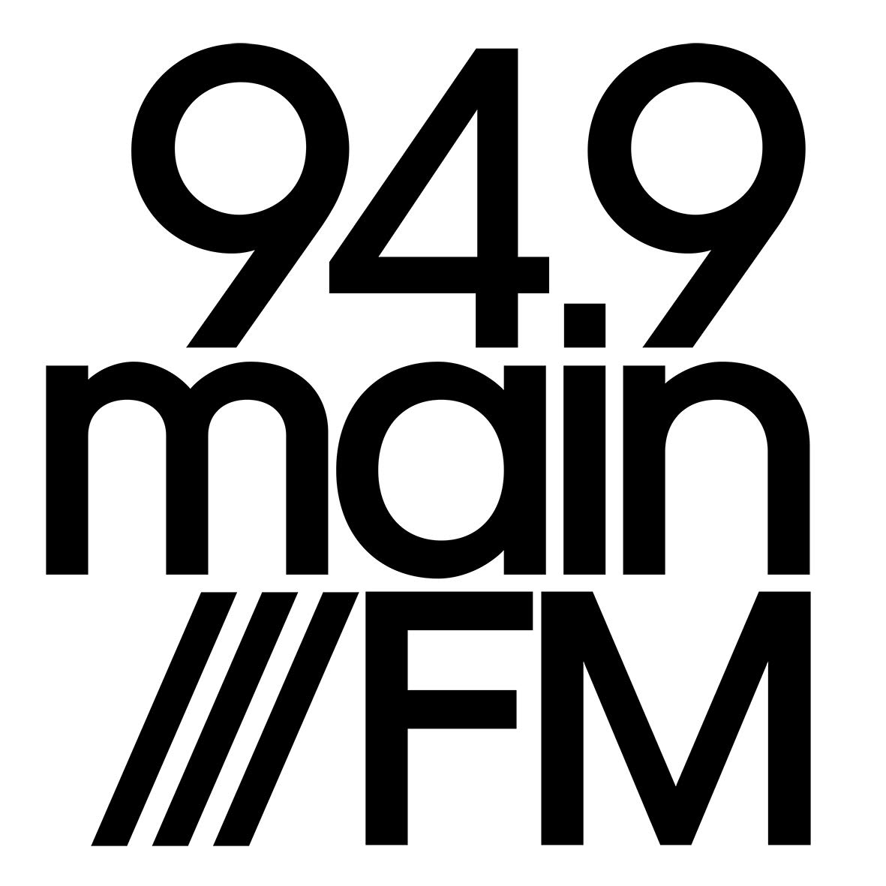

MAINfm PRESENTER’S HANDBOOK
Dear Presenters,
This handbook has been prepared to provide you with essential information about all aspects of your work at MAINfm. Please ensure you read, and understand its contents.
All presenters are required to undergo training before becoming a presenter and to be familiar with this handbook.

MAINfm Committee of Management

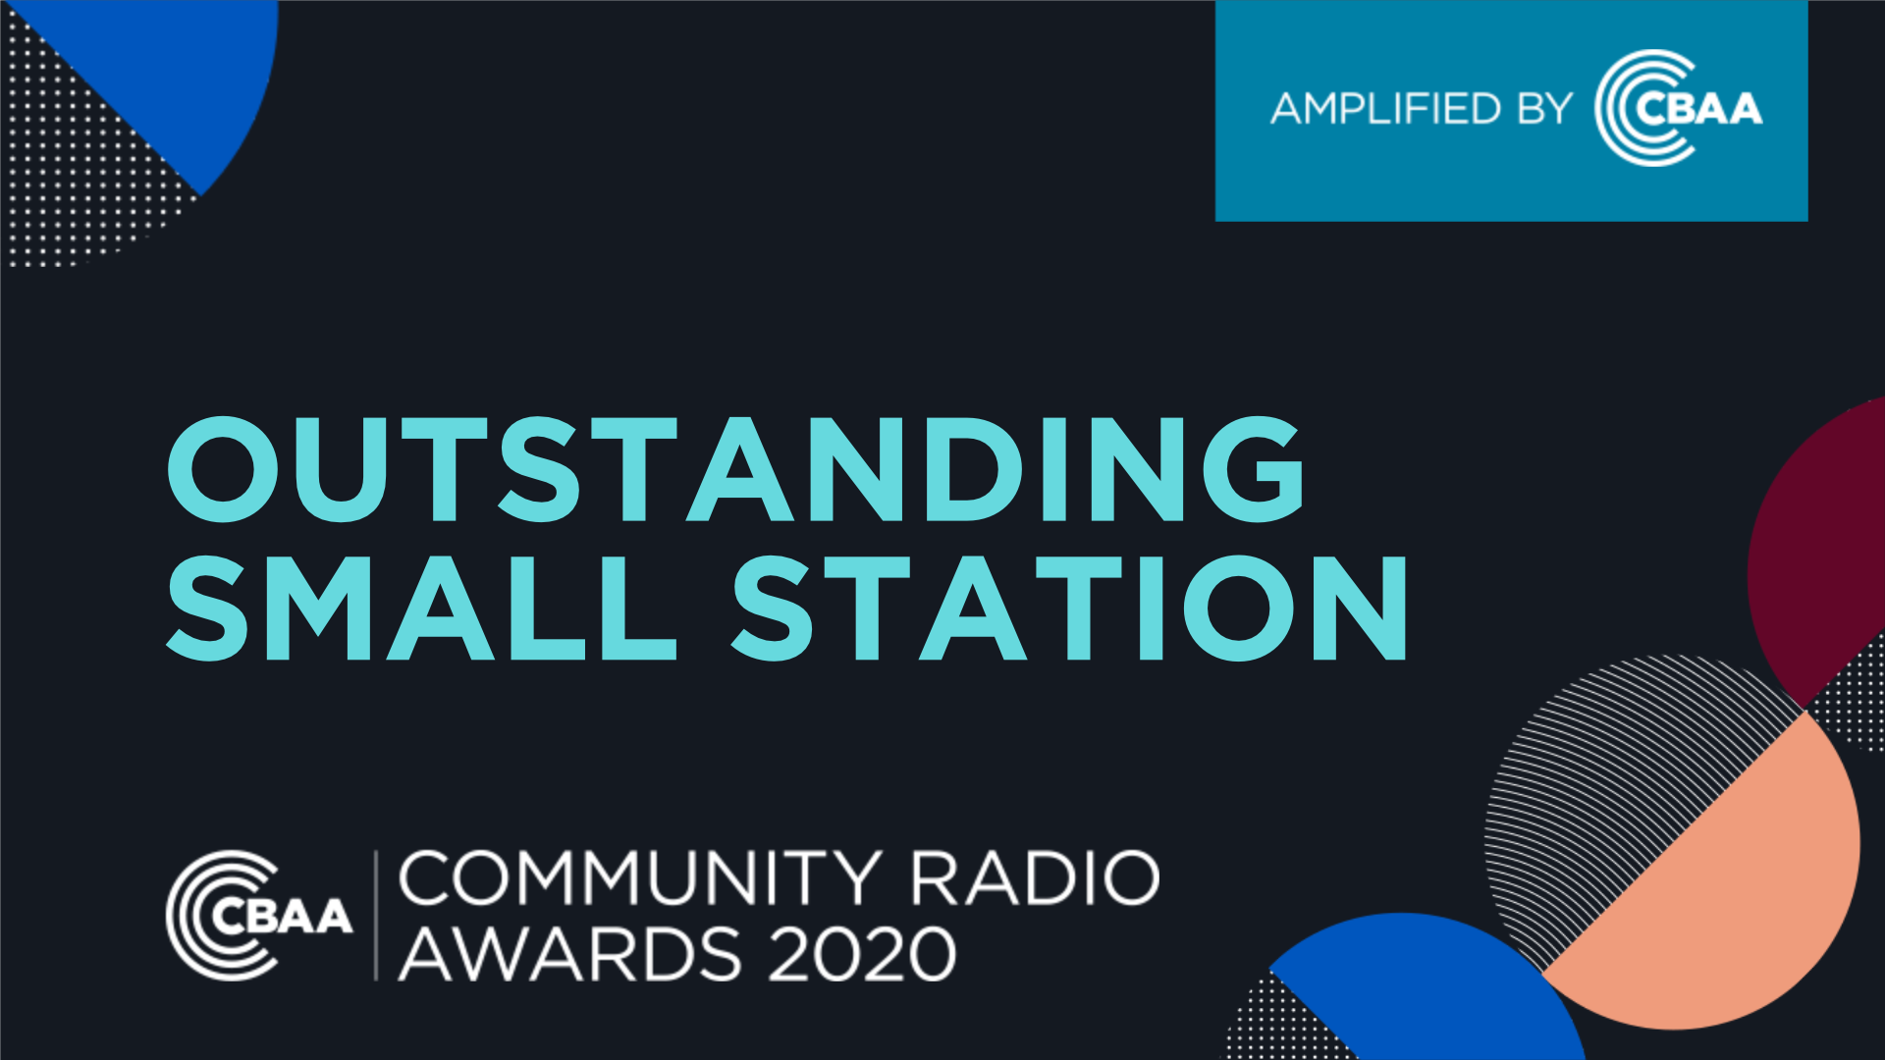

INDEX

- About MAINfm 3
- MAINfm’s Philosophy 4
- MAINfm’s Organisational Structure 5
- MAINfm’s Policies & Procedures 6
- MAINfm’s Regulatory environment 7
- MAINfm Presenters - Basic Operational Rules 8
- A Brief Guide to Broadcasting Law 9-10
- Copyright Laws 11
- Sponsorship Policy Guidelines 12
- Programs and Presenters 13
- Presenter Tips and Etiquette 14-16
- Live Broadcast 17
- Social Media and Promotion 18
- First Aid & Emergency contacts 19
- Glossary 20-21
- Acknowledgements 22

ABOUT MAINfm
94.9 MAINfm is an award-winning community radio station based in Castlemaine, broadcasting music, community news, talks and specialist programs, and events throughout a large area of Central Victoria.
MAINfm is a not-for-profit organisation which is owned and operated by and for the community and relies on sponsorship, grants, and listener subscriptions for its day-to-day broadcasting and administrative costs. Although primarily a volunteer organisation, our operating costs are quite high. With a few exceptions, all money must be raised locally. Grants are sought when the opportunity arises. All income generated is used for the development, improvement, conduct, and maintenance of the station.
The station operates from the Workspace building in Halford Street, Castlemaine with two staff members and over 100 volunteer presenters. Our call sign – MAINfm is representative of our base in Castlemaine, Victoria and our broader reach.
It is governed by an elected Committee of Management and is dedicated to creating an asset that resonates with and belongs to the broader community.
With over 850 subscribers, MAINfm is committed to ‘putting community into radio’ by broadcasting high quality radio 24 hours a day and streaming online.
Our presenters are locals and programs are varied and diverse with over 65 shows across the program grid, reflecting our community. Interested people in the community are welcome to become financial voting Members of Castlemaine District Radio Inc. or to become financial Subscribers to MAINfm.
Castlemaine District Radio Inc. is registered in Victoria. A0047091H
ABN 96 208 316 461

MAINfm PHILOSOPHY
MAINfm:

• Acknowledges we are broadcasting from Dja Dja Wurrung land.
• Celebrates and supports diversity.
• Is a Community radio station primarily operated by volunteers.
• Strives to provide a safe and harmonious work environment. Respect for all volunteers and staff and professional behaviour is part of your commitment to being involved in MAINfm.
• Acknowledges and nurtures its volunteer base by providing training, and by developing and evolving as a sustainable and ethical volunteer organisation.
• Reflects, discusses, and contributes to the ideas and issues important to the Mount
Alexander Shire community.
• Strives for excellence in broadcasting.
All positions within MAINfm require that you:
• Exercise care and respect when working with MAINfm volunteers and staff.
• Attend meetings and in-service training sessions as required.
• Work within the MAINfm team and abide by its policies.
• Respect issues of confidentiality. Therefore presenters must not comment, either on air or publicly, on any statements or decisions made by MAINfm management or Programming teams.
• Read and abide by all MAINfm policies, which are available on the website.
• Read and abide by all broadcasting laws, available from the office & online.

MAINfm’s ORGANISATIONAL STRUCTURE

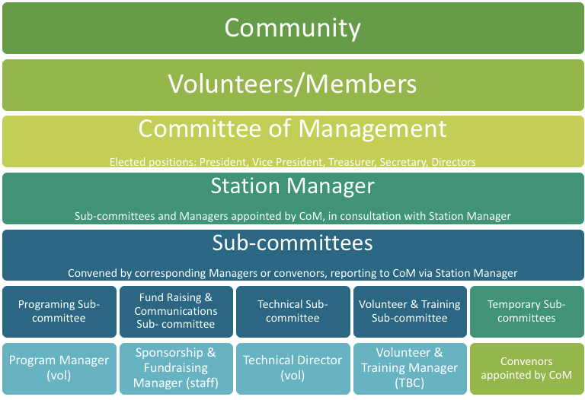

- Committee of Management Role Descriptions
- Current Committee of Management

MAINfm POLICIES & PROCEDURES
Below is a list of Policies which guide MAINfm’s operations. These can all be found on the website: www.mainfm.net/policies
Presenters should familiarise themselves with these Policies, as they form part of the membership agreement individuals make with MAINfm. Please click on the links below to find out more:

MAINfm Policies & Procedures
- Constitution November 2018
- Committee of Management Role Descriptions
- Community Participation Policy 2018
- Complaints and Grievance Policy 2016
- Governance Policy July 2018
- Harassment and Bullying Policy 2021
- Inclusion Policy 2021
- Membership Policy 2018
- Music Policy 2019
- Presenter’s Handbook 2017
- Program Policy 2019
- Sponsorship Policy 2021
- Volunteer Policy 2019
- Work Health and Safety Policy 2020
- Disclaimer

MAINfm Annual Reports
- MAINfm Annual Report 2019-20
- MAINfm Annual Report 2018-19
- MAINfm Annual Report 2017-18

MAINfm’s REGULATORY ENVIRONMENT
MAINfm operates within the guidelines and laws of three main bodies:

Australian Communications and Media Authority
ACMA is the independent statutory authority tasked with ensuring most elements of Australia’s media and communications legislation, related regulations, and numerous derived standards and codes of practice operate effectively and efficiently, and in the public interest.

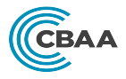
Community Broadcasting Association of Australia
The CBAA is the national peak body for community radio stations in Australia. The CBAA is responsible for sector advocacy and representation, providing services and benefits to their 300+ members and managing sector-wide projects.

Community Broadcasting Foundation
The CBF is an independent non-profit funding agency that seeks, secures, and distributes funding to support the development, creativity, and sustainability of community broadcasting in Australia.

MainFM PRESENTERS - BASIC OPERATIONAL RULES
Any individual or group wishing to be involved in presenting a program on MAINfm needs to have completed a membership application form and be a current financial member.
No person or group can have a regular program, or take control of the console, without having first reached an approved level of proficiency.
Any changes or additions to the program grid are the responsibility of the Programming Coordinator and Programming Committee.
Please record in the daybook if anything is found faulty, missing or broken in the on-air studio. It is located at reception.
Any person or group applying for a grant from any organisation or government authority, in relation to broadcasting on MAINfm Community Radio, must receive prior approval from the Station Manager and Committee of Management. Those wishing to seek sponsorship for their show should first discuss with the Sponsorship & Fundraising Manager.
The Station Management has the power to suspend a normal program in favor of an Outside Broadcast or special program as determined by the Committee of Management.
Smoking, eating or drinking in any studio is not permitted. Water is permitted in closed containers, but is not to be kept on the console desk.
Presenters are requested to play the promos in their allocated time slots. Not only are these important Station & Community announcements, but Sponsorship announcements are paid for by Station Sponsors - whose financial contributions help to keep the station on air.
All presenters are expected to volunteer a minimum of 6 hours per year volunteering at MAINfm. This could be at fundraising events, in the office, or at Outside Broadcasts.

A BRIEF GUIDE TO BROADCASTING LAW

Here is a very brief, but not definitive, guide to Broadcasting Law. For specific details consult the CBBA Codes of Practice.
As a presenter, you are responsible in law for what you broadcast. So is MAINfm. In the event of any court action, both you and the station are liable to summons.
The following are some key areas to be aware of:

Defamation
Any statement may be defamatory of a person if it tends to make reasonable people think worse of that person. A corporation may no longer be defamed. Courts tend to consider defamatory most words that reasonable people would not like to have said about themselves.
A few examples of defamatory material are:

• Disparaging, e.g. saying of a doctor, “they don’t know a thing about medicine.”
• Imputing dishonesty, e.g. “Alderman Jones gives contracts to their friends.”
• Alleging a person to be a criminal – even to say, “they are no better than a thief” is defamatory.
• Imputing a person has venereal disease, or a lack of sexual morals, is defamatory .

Blasphemous Defamation
Although prosecutions are rare, it is an offence to vilify any religion, belief system, or the texts and artefacts that are held sacred by such groups.

Seditious Defamation
This is when violence or public disorder is incited.

Injurious Falsehoods
This is similar to defamation, but involves broadcasting false statements about the quality of someone’s merchandise, their trading interests, etc.

Obscenity
Material is obscene if its effects tend to deprave or corrupt people likely to hear it. Depravity and corruption are not only viewed in sexual terms – material stressing favourable aspects of drug taking or advocating violence can also be considered obscene.

The law always tends to take a narrow view on what is publicly acceptable here. For instance, you cannot claim a program was aimed at mature and broadminded adults if there is any chance a young child might have tuned in.

As a general rule, the words ‘f...’ and ‘c...’ will always be regarded as obscene. Any obscene words or expressions must be preceded by warnings to the audience that the material that follows may be considered offensive. Warnings should be given across the whole show, where relevant. MAINfm’s broadcast licence is at risk if someone complains and we have not given a language warning before the offensive content.

It is not sufficient justification that a recording being played containing obscenities has been recorded and sold in shops. Broadcasting law is more specific, and some commercial recordings have been considered to be obscene presentations.

Contempt of Court
Contempt of Court consists of words that would obstruct the administration of justice. It includes comments on pending proceedings (which are subjudice, that is; under judicial consideration) and intemperate criticism of courts and judges.

To call a person’s death a murder, to say that the local judge goes soft on juvenile theft, to allege a crime before a court case has ruled it to be so, all constitute Contempt of Court. Particular care has to be exercised if interviewing witnesses to an (alleged) crime before it has gone to court. The jury may consider what is said on air in their deliberations, in which case the broadcast would be considered in contempt.

If in doubt, leave it out!

COPYRIGHT LAW

This is a very complex area, which even experts have difficulty in following. Copyright exists in every original literary, dramatic, or musical work. The author is the first owner, including the rights to perform, reproduce, publish or broadcast the work. The copyright continues until 50 years after the death of the original owner. Standard copyright agreements cover all commercial recordings.

However, you need to take particular steps before playing an independent recording, broadcasting a local production of a play or a live performance, etc. Copyright in these cases has to be cleared both with the performers and the writers of the material.

MAINfm pays a large annual fee (based on gross turnover and % of music played) to be licensed to broadcast music that is copyrighted by artists with APRA /AMCOS.

APRA/AMCOS
Australian Performing Rights Association/Australian Mechanical Copyright Owners

This licence payment enables MAINfm to broadcast music recorded by other artists and for a royalty to be shared back to the original content provider. It is also the license to record and broadcast AMCOS controlled production music sound recordings in announcements, station promotions, and station IDs.

Website: www.apraamcos.com.au

PPCA
Phonographic Performance Company

MAINfm also pays an annual fee to be licensed to broadcast sound recordings that are copyrighted by PPCA. Under this licence we:

• Must use best endeavours to announce the name of the artist or band and the title of each PPCA sound recording either immediately before or after the broadcast of such recording, or in as close proximity as possible.

• Must endeavour to include at least 25% of Australian music * within overall music programming and will encourage individual presenters to abide by this requirement

• Will complete logs as required.

Website: www.ppca.com.au

* MAINfm’s music policy encourages 30% Australian Music content where possible:
http://mainfm.net/wp-content/uploads/2019/06/Music-Policy-Approved-6.5.2019-1.pdf

SPONSORSHIP POLICY GUIDELINES

All sponsorship arrangements at MAINfm are organised by the Sponsorship Manager and signed off by the Committee of Management. This includes cash, non-profit, event, and personal sponsorship promotions. If a presenter knows someone who would be interested in sponsoring their show or MAINfm itself; please pass the name, contact details, and details of sponsorship interest, along to the Sponsorship Manager so we can formalise the arrangement.

Staying within Sponsorship Policy Guidelines On Air

• Interviews with guests from profit making, self-employed businesses and services
should be conducted with care and preparation to ensure that the business or
service is not specifically promoted. For example: you may interview a Tai Chi master
and discuss Tai Chi in general terms, but do not mention where their classes are or
their phone number.

• Musicians, artists and theatre persons who wish to promote their gigs, exhibitions or
plays are encouraged to donate tickets or copies of their releases to the station to be used for
giveaways. Even then care should be taken that the interview does not become an
advertisement. Giveaways can be arranged with the station staff.

• You are required by contract to play all Sponsorship Announcements that are in your show
folders at the time they are scheduled. Failure to do so results in breach of
contract with the Sponsor and MAINfm is legally obligated to honour the contract. If you
have any moral, religious, or ethical objection to a sponsorship announcement
scheduled on your program, please bring it to the attention of the Sponsorship Manager,
who will arrange for it to be replaced.

• The Station’s Community Broadcasting Licence allows for no more than 5 minutes per
hour of Sponsorship Announcements. Embellishment increases that time, and put
MAINfm in breach.

• You can say hello to friends at their place of work but do not embellish on the
business where they are working (e.g. “The best food in town!”)

• It is your responsibility to fully understand the policies and procedures of
Sponsorship that are set down in the CBAA Codes of Practice: www.cbaa.org.au

• Any breaches of this policy could lead to warnings and subsequent suspension of your program.
PROGRAMS AND PRESENTERS

• If your program submission is accepted, the presenters and program style must
remain as submitted. Any change in presenters or program style must have prior
consent from the Programming Coordinator.

• Placement of programs is based on individual presenter eligibility and the style of the
program as it fits into the overall sound of the station and the program grid as
developed by the Committee of Management.

• MAINfm values all of its presenters. However, it should be noted that: The current
On-Air Presenter is considered the most important person in the station! The On-Air
Presenter is projecting the image of MAINfm in the minds of the local community as
well as the visitors. So please Do Not Disturb the On-Air Presenter unless it is urgent.

• All presenters, including co-presenters, are required to be current financial
members. MAINfm has between 90 and 100 trained presenters in any given program
period. Regular presenters who are unable to cover their program are responsible for
organising a replacement presenter or a pre recorded program.

• Back-Up Presenters must be fully paid members and have completed presenter
training. They are obligated to play all scheduled announcements.

• Note that presenters doing programs outside of Office Hours need station access. Access codes will be provided by Station Management.

• Presenters planning a temporary break from presenting their show should notify The
Program Coordinator or Station Manager by phone and or email. Presenters
should consider pre recording their programs or repackaging older saved programs to
fill in the gap until their return. Extended absences may result in the program’s timeslot
being classified as “vacant”

PRESENTER TIPS AND ETIQUETTE
Shows before and after yours.
• Get the phone numbers of the presenters on either side of your show – the office is not a message service, it is up to you to let them know if you are running late, away or have loaded up a pre-recorded show when you usually go live. If you do not let them know they will not know how to announce your show.
• Thank the show before ie: “Thanks to X and Y from ‘That Show’, for the last two
hours”. If you don’t have anything nice to say, don’t say anything other than what is
written above. If you have trouble remembering names, write them down - and get the
name of the presenter and the show correct!
• At the end of your show announce the show immediately following and those
following ie: “Thanks for listening, coming up next is Z with ‘Next Show’ and after that
is Q with ‘Show After Name’. So stay tuned to MAINfm”.
• If there is no show before or after your just say ‘You are listening to MAINfm’ and ‘stay tuned to MAINfm’
How to sound good On Air
• Think of your audience as just one person - you are broadcasting straight to them. This will make you sound much more resonant and personal.
• Stay one hand span away from the microphone so you don’t pop (the sound) but talk straight into the microphone, as they are quite directional.
• Speak slowly and clearly and if you want to really get people’s attention- whisper! (Be careful of the levels though!)
• Try not to say UM – but we are all human so, um, some hesitations are inevitable.
• Don’t be afraid of pauses. A bit of dead air is riveting.
• Smiling when you talk makes you sound automatically friendlier.
Idents, interaction and the Weather.
• People like to hear what time it is. Even if they have a watch- or a phone and check out the weather forecast and let people know that too. It makes for good companion radio - which is what we are!
• Mention MAINfm regularly (approx. every 15 minutes) ‘you’re listening to MAINfm, my name is X and this is My Show Name’
• Talk about how people can interact with the station. They can subscribe, can listen online, can go to our website, can like us on Facebook/Instagram etc
• Play the station ID’s stored in Zara!
Faults

• If you are struggling with tech or something is not working, try to just keep talking as
you fix it, if it is really taking ages to work, then say ‘sorry folks, I’m having some
technical difficulties, hopefully the song will play in just a moment.’ A few seconds of
silence is not the end of the world, and is better than constantly apologising or blaming
the tech.

• Always have a different type of music on back up – so if you only use records, have a
CD ready to go as back up, or something in Zara, or something lined up on via an online
Source. That way you can use this back up if your preferred tech fails for some reason.

MAJOR FAULTS:
If there are technical problems that mean nothing is going to air or
your show is severely impacted, please call the phone numbers on the wall. These
people can talk you through any problems you might be having. If the first person
does not pick up then call the next one!

MINOR FAULTS:
If the technical problems are less urgent or just irritating but not
debilitating, please make a note of them in the Faults Book, which lives on the stand
with the sign in sheets. Please do make note of anything that you notice isn’t working
right, we often won’t know there is anything wrong unless you tell us.
Introductions and Back Announcing

• Don’t forget to back announce who you have just been talking to, or the music you
just played.

• It’s good to introduce your guest before you speak to them, but it’s vital to tell the
audience whom they have just been listening to, especially as they were so interesting!

SPONSORSHIP ANNOUNCEMENTS
• We need to pay over $5000 per month in basic expenses to stay on air- so don’t forget to encourage everyone to become subscribers to the station, or to encourage businesses to get in touch regarding Sponsorship of MAINfm.
• When referring to Sponsorship Announcements and promos do not call them advertisements!
• You don’t have to refer to them at all if you put them between songs.
• Do not talk about a sponsor’s business at all, it may be considered extra advertising for them and is not fair to the other sponsors.
• Only speak in positive or neutral terms about the announcements. You can say ‘Our lovely sponsors who keep the station going’ or ‘Important announcements from our valued sponsors. Or just keep it neutral: ‘Now It’s time for some announcements’
• Do not moan, groan or sound apologetic or bored by them. Our sponsors are very important to the station and allow us to exist so you can run your show.
• Never make fun of a promo or Sponsor announcement, no matter how tired of it you are, how dumb you think it sounds etc.

Promote your stations Fundraisers
• There is always a fundraiser or an Outside Broadcast coming up - the notices for those are usually on the board too - please remind people to come along (or come yourselves).
• Remember part of your responsibility, as a presenter is to volunteer for at least 6 hours a year on one of the many fundraising activities that are often done by the same people time and time again.

Tidy up
• Keep the studios tidy, take any rubbish out with you, clean your own dishes. No one here is your servant, There is a vacuum that you can use if you would like to help keep the place tidy and feel free to wipe benches, dust or tidy up in general.
• We are all volunteers and we don’t have enough money to hire a cleaner, so it is up to all of us to keep the place nice.

LIVE BROADCAST TIPS
• Be aware of both of your audiences. You now have to talk to not only the people in the live audience, but the people who are listening as well. These people can’t see the visual gags or cues.

• You could try to make a bit more commentary on the visual aspects of the night, as
long as it sounds natural. Eg. ‘What a great outfit – so much sparkle going on’ is
enough to give the radio audience an insight into what is going on.

• If something happens that everyone is obviously reacting to you can say things like ‘For those of you listening at home x and y just happened’

Talk about MAINfm - for example:

• ‘Big shout out to everyone listening at home on MAINfm 94.9’

• ‘We are here at The Castlemaine Botanic Gardens for the Pride Picnic, having a great time with the guests and live music, I hope you are having as much fun listening at home on MAINfm 94.9’

• ‘We encourage everyone listening at home on MAINfm 94.9 to come on down to Victory Park, it is such a fun night…’

SOCIAL MEDIA AND PROMOTION OF YOUR SHOW
MAINfm encourages presenters, volunteers and employees to use social media such as Facebook, Instagram & Twitter to engage with listeners and supporters of the station and their show. Invite your friends to like the MAINfm Facebook back - and to the Friends of MAINfm group to help increase our social media presence.
MAINfm presenters are responsible for any content they post on MAINfm and personal social media accounts and sites, as is MAINfm.
The following standards apply to all MAINfm members & presenters and their use of MAINfm and personal interactive services.
• Do not conduct any activity which is likely to bring MAINfm into disrepute.
• Do not defame or vilify any person or organisation.
• Do not imply MAINfm endorsement of your personal views.
• Be respectful of our listening public and of all individuals involved in MAINfm.
• Do not disclose confidential information obtained through interaction at MAINfm.
• Do not engage in any process, petitioning or public statements about any MAINfm policies or decisions.
• MAINfm will enforce these standards as and when appropriate. Breaches of this policy may lead to disciplinary action.

FIRST AID
• MAINfm has a basic first Aid kit available in the Office – should you or guests need it.
• If you do open and use ANY item from the First Aid kit please complete the incident form. This means one panadol or one band-aid – ANY use must be recorded. We must record all uses of the first aid kit to ensure the Kit is correctly maintained and to ensure we (MAINfm) are aware of all incidents at the station.
• MAINfm and the presenter may be held legally liable for incorrect use of any medical equipment.

For example:
I took two panadols on June 13 because I had a headache, signed ‘presenter name’.
OR
On June 14, I sprained my arm tripping over and used the bandages to make a sling before I went to the hospital, signed ‘presenter name’.

EMERGENCY CONTACTS

Emergency (inc Ambulance) - Dial 000
Castlemaine Police Station – 5470 4100
Vic Emergency Hotline – 1800 226 226
CFA Website http://www.cfa.vic.gov.au
CFA Headquarters – 03 9262 8444
Burn-off Notifications – 1800 668 511

Castlemaine Health
142 Cornish Street, Castlemaine
Phone Enquiries/ Hospital (03) 5471 1555

MAINfm Personnel – A phone list is posted at the reception desk.

GLOSSARY
(ACMA) Australian Communications and Media Authority: The major Commonwealth broadcasting regulatory authority which oversees the operations of the commercial ‘free to air’ and ‘Pay TV’ and community radio and television broadcasting sectors, as well as being highly likely to regular on-line computer delivery services. Established by the Broadcasting Services Act of 1992 (as amended.)

Back Announce: Provision of information following the conclusion of an item – at the end of a music track, for example.
Console: The panel that contains the technologies to mix the components involved in the presentations of radio programs or productions.
Cross Fade: A form of segue. Fading in a sound source while another source fades out, but maintaining an equal volume level. Also applies when a program needs to be presented without interruption but its duration requires a number of tapes.
(CSA) Community Service Announcement: This is a free service offered to all non- profit, community organizations.
Cue has two meanings:
• Firstly, the indication of the end of an item, usually the last few words of a sentence.
• Secondly, to prepare a recording for presentation so as to eliminate dead air.

Db: Abbreviation for decibel, a unit of sound loudness. Dead Air: A gap in the program, silence where sound should be.

Demographics: Statistical information related to the structure of an audience regarding age, gender, marital status etc.
Fade: Apart from its obvious connotation, as an out-cue it signifies that the music fades at the end of the cart / mini-disc / CD, or as a script instruction that the music or sound effect should diminish in volume.
Fader: Is the controller of sound volume from nil to the capacity on the studio desk. Also known as a pot, slider, attenuator
Feedback: The howling effect that is generated when sound from a loud speaker or headphones is picked up by a microphone and re amplified.
(FM) Frequency Modulation: An improvement on AM because of almost noise free transmission, but is limited in coverage due to its “line of sight” signal. Instead of the height or amplitude of the signal being varied, the frequency of the signal varies within a strictly determined bandwidth. Typically broadcast in the VHF Band, ie.88-108 MhZ.

Hertz: Cycles per second.
Kilohertz: One thousand Hertz.
Megahertz: A million cycles per second

Level: The reading on a VU meter indicating audio energy in the program channel.

Popping: Small explosive sound created by blasts of air into a microphone; most frequently from words starting with ‘P’. In Audacity these can be removed for recorded items using the ‘effects’ option. (‘Click’ removal).
Pre-Announce: Provide information on-air concerning an item about to be played, also called Forward announce
Promo: The name for any promotional spot designed to create awareness of a forthcoming feature, sponsored or unsponsored. Segue pronounced “SEG-WAY”. Commonly used to describe the playing of two records/CDs back-to-back with minimal or no silence between them.
(SFX) Sound Effects: The abbreviation of “sound effects”
Sponsor: The person or organization identified with the announcement or program paid for by the advertiser.
Sting: A production effect that can be electronic, musical or a sound effect. Used for punctuation at the start, within or at the end of recorded spots.
VU Meter: A volume meter situated on the studio console to measure and indicate loudness of sound. They can be either in conventional meter form or LED.
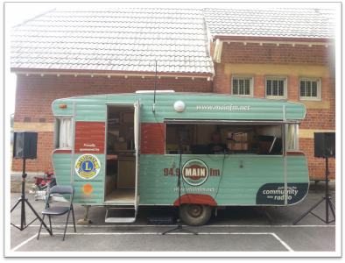

Acknowledgments:
To create this handbook we have drawn from a variety of sources and being a not for profit we greatly appreciate their support. The basic template was originally drawn from BayFm in Byron Bay, specialist notes and tips from past and present MAINfm presenters, Committee members, volunteers & staff, CBAA, the Community Media Training Organisation (CMTO).

